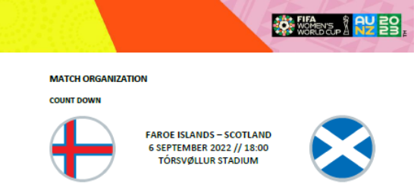

Time | Duration | Schedule
13:30 | 1 hour | Completion of disinfection of Zone 1
16:30 | 15 minutes | Latest arrivals of teams
16:45 | 15 minutes | Match sheet to be submitted
17:00 | 15 minutes | 4th Official’s first equipment check
17:15 | ½ hour | Start of warm-up on pitch
17:45 | 8 minutes | End of warm-up on pitch/teams return to dressing room
17:45 | 8 minutes | Official match ball in position
17:52 | 1 minute | Assistant referees leave dressing room for studs check with teams
17:53 | 1 minute | Teams leave dressing rooms – studs checked as they leave
17:54 | 30 seconds | Teams exit to pitch
17:54.30 | 1 minute | Team delegations (including substitutes) to go to pitch side
17:55.30 | 2 minutes | Teams line-up on pitch
 |  | National Anthem – Scotland team (78 seconds)
 |  | National Anthem – Faroe Islands team (61 seconds)
17:57.30 | 1½ minutes | Team photos
17:59 | 1 minute | Coin toss (referees and team captains)
18:00 | 45 minutes | Kick-off
18:45 | 13½ minutes | Half time (depending on additional time)
18:58.30 | 1 minute | Teams leave dressing rooms for 2nd half
18:59.30 | 30 seconds | Teams back on pitch for 2nd half
19:00 | 45 minutes | Kick off 2nd half after exactly 15 minutes
19:45 |  | Full time (depending on additional time)

